A

Report

Of

Industrial Training

On

ARTIFICIAL INTELLIGENCE

Submitted in partial fulfilment for the award of degree of

Bachelor of Technology

In

Computer Science and Engineering



Submitted By: Guide:

Name: Arushi Jain Ms. Shaina Arora

Roll No. 20EJCCS054 Assistant Professor

Department of Computer Science and Engineering

Jaipur Engineering College and Research Centre

Jaipur, Rajasthan

2023-24

CERTIFICATE

This is to certify that the industrial training entitled **“ARTIFICIAL INTELLIGENCE**” is the bonafide work carried out by **ARUSHI JAIN** student of B.Tech. in Computer Science & Engineering at Jaipur Engineering College and Research Centre, during the year 2023-24 in partial fulfillment of the requirements for the award of the Degree of Bachelor of Technology in Computer Science & Engineering under my guidance.

**Name of Guide: Ms. Shaina Arora**

**Designation: Assistant** **Professor**

**Place: Jaipur**

**VISION OF CSE DEPARTMENT**

To become renowned Centre of excellence in computer science and engineering and make competent engineers & professionals with high ethical values prepared for lifelong learning.

**MISSION OF CSE DEPARTMENT**

1. To impart outcome based education for emerging technologies in the field of computer science and engineering.
2. To provide opportunities for interaction between academia and industry.
3. To provide platform for lifelong learning by accepting the change in technologies
4. To develop aptitude of fulfilling social responsibilities.

**PROGRAM OUTCOMES (POs)**

1. **Engineering knowledge:** Apply the knowledge of mathematics, science, engineering fundamentals, and an engineering specialization to the solution of complex engineering problems.
2. **Problem analysis:** Identify, formulate, research literature, and analyze complex engineering problems reaching substantiated conclusions using first principles of mathematics, natural sciences, and engineering sciences.
3. **Design/development of solutions:** Design solutions for complex engineering problems and design system components or processes that meet the specified needs with appropriate consideration for the public health and safety, and the cultural, societal, and environmental considerations.
4. **Conduct investigations of complex problems:** Use research-based knowledge and research methods including design of experiments, analysis and interpretation of data, and synthesis of the information to provide valid conclusions.
5. **Modern tool usage:** Create, select, and apply appropriate techniques, resources, and modern engineering and IT tools including prediction and modeling to complex engineering activities with an understanding of the limitations.
6. **The engineer and society:** Apply reasoning informed by the contextual knowledge to assess societal, health, safety, legal and cultural issues and the consequent responsibilities relevant to the professional engineering practice.
7. **Environment and sustainability:** Understand the impact of the professional engineering solutions in societal and environmental contexts, and demonstrate the knowledge of, and need for sustainable development.
8. **Ethics:** Apply ethical principles and commit to professional ethics and responsibilities and norms of the engineering practice.
9. **Individual and team work**: Function effectively as an individual, and as a member or leader in diverse teams, and in multidisciplinary settings.
10. **Communication**: Communicate effectively on complex engineering activities with the engineering community and with society at large, such as, being able to comprehend and write effective reports and design documentation, make effective presentations, and give and receive clear instructions.
11. **Project management and finance**: Demonstrate knowledge and understanding of the engineering and management principles and apply these to one’s own work, as a member and leader in a team, to manage projects and in multidisciplinary environments.
12. **Life-long learning**: Recognize the need for, and have the preparation and ability to engage in independent and life-long learning in the broadest context of technological change.

**PROGRAM EDUCATIONAL OBJECTIVES (PEOs)**

The PEOs of the B.Tech (CSE) program are:

1. To produce graduates who are able to apply computer engineering knowledge to provide turn-key IT solutions to national and international organizations.
2. To produce graduates with the necessary background and technical skills to work professionally in one or more of the areas like – IT solution design development and implementation consisting of system design, network design, software design and development, system implementation and management etc. Graduates would be able to provide solutions through logical and analytical thinking.
3. To able graduates to design embedded systems for industrial applications.
4. To inculcate in graduates effective communication skills and team work skills to enable them to work in multidisciplinary environment.
5. To prepare graduates for personal and professional success with commitment to their ethical and social responsibilities.

**PROGRAM SPECIFIC OUTCOMES (PSOs)**

* + PSO1: Ability to interpret and analyze network specific and cyber security issues in real world environment.
  + PSO2: Ability to design and develop mobile and web-based applications under realistic constraints.

**COURSE OUTCOMES (COs)**

On completion of project Graduates will be able to-

* CO1: Generate the report based on the Projects carried out for demonstrating the ability to apply the knowledge of engineering field during training
* CO2: Demonstrate Competency in relevant engineering fields through problem identification, formulation and solution.

## **MAPPING: CO's & PO's**

|  |  |  |  |  |  |  |  |  |  |  |  |  |  |
| --- | --- | --- | --- | --- | --- | --- | --- | --- | --- | --- | --- | --- | --- |
| **Subject Code** | **Cos** | **Program Outcomes (POs)** | | | | | | | | | | | |
| **PO-**  **1** | **PO-**  **2** | **PO-**  3 | **PO-**  **4** | **PO-**  5 | **PO- 6** | **PO-**  7 | **PO- 8** | **PO- 9** | **PO-**  **10** | **PO-**  **11** | **PO-**  **12** |
| **3CS7-30**  Industrial Training | **CO-1** | 3 | 3 | 2 | 2 | 2 | 1 | 1 | 2 | 2 | 3 | 3 | 3 |
| **CO-2** | 3 | 3 | 3 | 3 | 3 | 1 | 1 | 2 | 2 | 3 | 3 | 3 |

**ACKNOWLEDGEMENT**

It has been a great honour and privilege to undergo training at **Upflairs**, Jaipur. I am very grateful to Mr. Sanam giving his valuable time and constructive guidance in preparing the report for training. It would not have been possible to complete this report in short period of time without their kind encouragement and valuable guidance.

I wish to express our deep sense of gratitude to our Seminar Guide **Ms. Shaina Arora**, Jaipur Engineering College and Research Centre, Jaipur for guiding us from the inception till the completion of the seminar. We sincerely acknowledge him for giving his valuable guidance, support for literature survey, critical reviews and comments for our seminar.

I would like to first of all express our thanks to **Mr. Arpit Agrawal** Director of JECRC, for providing us such a great infrastructure and environment for our overall development.

I express sincere thanks to **Dr. V. K. Chandna**, Principal of JECRC, for his kind cooperation and extendible support towards the completion of our seminar.

Words are inadequate in offering our thanks to **Dr. Sanjay Gaur,** HOD of CSE department, for consistent encouragement and support for shaping our seminar in the presentable form.

Also our warm thanks to **Jaipur Engineering College and Research Centre**, who provided us this opportunity to carryout, this prestigious seminar and enhance our learning in various technical fields.

**Name: Arushi Jain**

**Roll No.: 20EJCCS054**

**ABSTRACT**

As we know Python is an emerging language so it becomes easy to write a script for Voice

Assistant in Python. The instructions for the assistant can be handled as per the requirement

of user. Speech recognition is the process of converting speech into text. This is commonly

used in voice assistants like Alexa, Siri, etc. In Python there is an API called

SpeechRecognition which allows us to convert speech into text. It was an interesting task

to make my own assistant. It became easier to send emails without typing any word,

Searching on Google without opening the browser, and performing many other daily tasks

like playing music, opening your favorite IDE with the help of a single voice command. In

the current scenario, advancement in technologies are such that they can perform any task

with same effectiveness or can say more effectively than us. By making this project, I

realized that the concept of AI in every field is decreasing human effort and saving time.

Functionalities of this project include:

1. It can send emails.

2. It can read PDF.

3. It can send text on WhatsApp.

4. It can open command prompt, your favorite IDE, notepad etc.

5. It can play music.

6. It can do Wikipedia searches for you.

7. It can open websites like Google, YouTube, etc., in a web browser.

8. It can give weather forecast.

9. It can give desktop reminders of your choice.

10. It can have some basic conversation.

Now the basic question arises in mind that how it is an AI? The virtual assistant that I have

created is like if it is not an A.I, but it is the output of a bundle of the statement. But

fundamentally, the mail purpose of A.I machines is that it can perform human tasks with the

same efficiency or even more efficiently than humans. It is a fact that my virtual assistant is

not a very good example of A.I., but it is an A.I.

As we know Python is an emerging language so it becomes easy to write a script for Voice

Assistant in Python. The instructions for the assistant can be handled as per the requirement

of user. Speech recognition is the process of converting speech into text. This is commonly

used in voice assistants like Alexa, Siri, etc. In Python there is an API called

SpeechRecognition which allows us to convert speech into text. It was an interesting task

to make my own assistant. It became easier to send emails without typing any word,

Searching on Google without opening the browser, and performing many other daily tasks

like playing music, opening your favorite IDE with the help of a single voice command. In

the current scenario, advancement in technologies are such that they can perform any task

with same effectiveness or can say more effectively than us. By making this project, I

realized that the concept of AI in every field is decreasing human effort and saving time.

Functionalities of this project include:

1. It can send emails.

2. It can read PDF.

3. It can send text on WhatsApp.

4. It can open command prompt, your favorite IDE, notepad etc.

5. It can play music.

6. It can do Wikipedia searches for you.

7. It can open websites like Google, YouTube, etc., in a web browser.

8. It can give weather forecast.

9. It can give desktop reminders of your choice.

10. It can have some basic conversation.

Now the basic question arises in mind that how it is an AI? The virtual assistant that I have

created is like if it is not an A.I, but it is the output of a bundle of the statement. But

fundamentally, the mail purpose of A.I machines is that it can perform human tasks with the

same efficiency or even more efficiently than humans. It is a fact that my virtual assistant is

not a very good example of A.I., but it is an A.I.

As we know Python is an emerging language so it becomes easy to write a script for Voice

Assistant in Python. The instructions for the assistant can be handled as per the requirement of user. Speech recognition is the process of converting speech into text. This is commonly used in voice assistants like Alexa, Siri, etc. In Python there is an API called Speech Recognition which allows us to convert speech into text. It was an interesting task to make my own assistant. It became easier to send emails without typing any word, Searching on Google without opening the browser, and performing many other daily tasks like playing music, opening your favourite IDE with the help of a single voice command. In the current scenario, advancement in technologies are such that they can perform any task with same effectiveness or can say more effectively than us. By making this project, I realized that the concept of AI in every field is decreasing human effort and saving time. Functionalities of this project include:

1. It can send emails.

2. It can read PDF.

3. It can send text on WhatsApp.

4. It can open command prompt, your favourite IDE, notepad etc.

5. It can play music.

6. It can do Wikipedia searches for you.

7. It can open websites like Google, YouTube, etc., in a web browser.

8. It can give weather forecast.

9. It can give desktop reminders of your choice.

10. It can have some basic conversation.

Now the basic question arises in mind that how it is an AI? The virtual assistant that I have created is like if it is not an A.I, but it is the output of a bundle of the statement. But fundamentally, the mail purpose of A.I machines is that it can perform human tasks with the same efficiency or even more efficiently than humans. It is a fact that my virtual assistant is not a very good example of A.I., but it is an A.I.

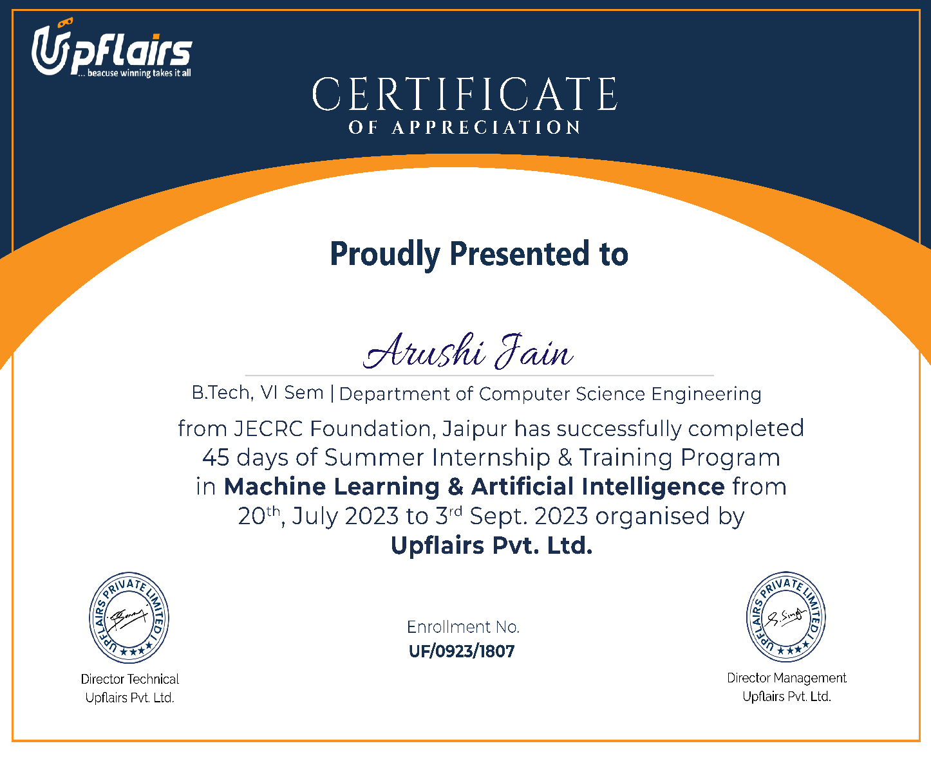 **CERTIFICATE** **TABLE OF CONTENTS**

**Certificate----------------------------------------------------------------------------------------- i**

**Vision and Mission------------------------------------------------------------------------------- ii**

**Program Outcomes (POs)----------------------------------------------------------------------- iii**

**Program Education Objectives (PEOs) ------------------------------------------------------ iv**

**Program Specific Outcomes (PSOs)----------------------------------------------------------- v**

**Course Outcomes (COs)------------------------------------------------------------------------- vi**

**Mapping: COs and POs-------------------------------------------------------------------------- vi**

**Acknowledgement--------------------------------------------------------------------------------- vii**

**Abstract---------------------------------------------------------------------------------------------- viii**

**List of Figures--------------------------------------------------------------------------------------- ix**

**List of Tables---------------------------------------------------------------------------------------- x**

**1. INTRODUCTION------------------------------------------------------------------------------**

* 1. Purpose ---------------------------------------------------------------------------------------
  2. Project Scope---------------------------------------------------------------------------------
  3. Document Convention ----------------------------------------------------------------------

**2. REQUIREMENT ANALYSIS---------------------------------------------------------------**

2.1 Hardware Requirement---------------------------------------------------------------------

2.2 Software Requirement ----------------------------------------------------------------------

2.3 Functional Requirement---------------------------------------------------------------------

2.4 Non Functional Requirements ------------------------------------------------------------

2.5 User Classes and Characteristics -----------------------------------------------------------

**3. SYSTEM DESIGN-------------------------------------------------------------------------------**

3.1 Use Case Diagram---------------------------------------------------------------------------

3.2 Data Base Design and Databases ---------------------------------------------------------

3.3 Sequence Diagram/Activity Diagram------------------------------------------------------

3.4 Deployment Diagram ----------------------------------------------------------------------

**4. Artificial Intelligence------------------------------------------------------------------------------**

**5. Screenshots___________________________________________________________**

**5. Conclusion -----------------------------------------------------------------------------------------**

* 1. **INTRODUCTION**

1. Artificial Intelligence when used with machines, it shows us the capability of
2. thinking like humans. In this, a computer system is designed in such a way that typically
3. requires interaction from human. As we know Python is an emerging language so it
4. becomes easy to write a script for Voice Assistant in Python. The instructions for the
5. assistant can be handled as per the requirement of user. Speech recognition is the Alexa,
6. Siri, etc. In Python there is an API called Speech Recognition which allows us to
7. convert speech into text. It was an interesting task to make my own assistant. It became
8. easier to send emails without typing any word, Searching on Google without opening
9. the browser, and performing many other daily tasks like playing music, opening your
10. favorite IDE with the help of a single voice command. In the current scenario,
11. advancement in technologies are such that they can perform any task with same
12. effectiveness or can say more effectively than us. By making this project, I realized that
13. the concept of AI in every field is decreasing human effort and saving time.
14. As the voice assistant is using Artificial Intelligence hence the result that it is
15. providing are highly accurate and efficient. The assistant can help to reduce human
16. effort and consumes time while performing any task, they removed the concept of
17. typing completely and behave as another individual to whom we are talking and asking
18. to perform task. The assistant is no less than a human assistant but we can say that this
19. is more effective and efficient to perform any task. The libraries and packages used to
20. make this assistant focuses on the time complexities and reduces time.
21. The functionalities include , It can send emails, It can read PDF, It can send text
22. on WhatsApp, It can open command prompt, your favorite IDE, notepad etc., It can play
23. music, It can do Wikipedia searches for you, It can open websites like Google,
24. YouTube, etc., in a web browser, It can give weather forecast, It can give desktop
25. reminders of your choice. It can have some basic conversation.
26. Tools and technologies used are PyCharm IDE for making this project, and I
27. created all py files in PyCharm. Along with this I used following modules and libraries
28. in my project. pyttsx3, SpeechRecognition, Datetime, Wikipedia, Smtplib, pywhatkit,
29. pyjokes, pyPDF2, pyautogui, pyQt etc. I have created a live GUI for interacting with
30. the JARVIS as it gives a design and interesting look while having the conversation.

Artificial Intelligence when used with machines, it shows us the capability of

thinking like humans. In this, a computer system is designed in such a way that typically

requires interaction from human. As we know Python is an emerging language so it

becomes easy to write a script for Voice Assistant in Python. The instructions for the

assistant can be handled as per the requirement of user. Speech recognition is the Alexa,

Siri, etc. In Python there is an API called Speech Recognition which allows us to

convert speech into text. It was an interesting task to make my own assistant. It became

easier to send emails without typing any word, Searching on Google without opening

the browser, and performing many other daily tasks like playing music, opening your

favorite IDE with the help of a single voice command. In the current scenario,

advancement in technologies are such that they can perform any task with same

effectiveness or can say more effectively than us. By making this project, I realized that

the concept of AI in every field is decreasing human effort and saving time.

As the voice assistant is using Artificial Intelligence hence the result that it is

providing are highly accurate and efficient. The assistant can help to reduce human

effort and consumes time while performing any task, they removed the concept of

typing completely and behave as another individual to whom we are talking and asking

to perform task. The assistant is no less than a human assistant but we can say that this

is more effective and efficient to perform any task. The libraries and packages used to

make this assistant focuses on the time complexities and reduces time.

The functionalities include , It can send emails, It can read PDF, It can send text

on WhatsApp, It can open command prompt, your favorite IDE, notepad etc., It can play

music, It can do Wikipedia searches for you, It can open websites like Google,

YouTube, etc., in a web browser, It can give weather forecast, It can give desktop

reminders of your choice. It can have some basic conversation.

Tools and technologies used are PyCharm IDE for making this project, and I

created all py files in PyCharm. Along with this I used following modules and libraries

in my project. pyttsx3, SpeechRecognition, Datetime, Wikipedia, Smtplib, pywhatkit,

pyjokes, pyPDF2, pyautogui, pyQt etc. I have created a live GUI for interacting with

the JARVIS as it gives a design and interesting look while having the conversation.

Artificial Intelligence when used with machines, it shows us the capability of thinking like humans. In this, a computer system is designed in such a way that typically requires interaction from human. As we know Python is an emerging language so it becomes easy to write a script for Voice Assistant in Python. The instructions for the assistant can be handled as per the requirement of user. Speech recognition is the Alexa, Siri, etc. In Python there is an API called Speech Recognition which allows us to convert speech into text. It was an interesting task to make my own assistant. It became easier to send emails without typing any word, Searching on Google without opening the browser, and performing many other daily tasks like playing music, opening your favourite IDE with the help of a single voice command. In the current scenario, advancement in technologies are such that they can perform any task with same effectiveness or can say more effectively than us. By making this project, I realized that the concept of AI in every field is decreasing human effort and saving time. As the voice assistant is using Artificial Intelligence hence the result that it is providing are highly accurate and efficient. The assistant can help to reduce human effort and consumes time while performing any task, they removed the concept of typing completely and behave as another individual to whom we are talking and asking to perform task. The assistant is no less than a human assistant but we can say that this is more effective and efficient to perform any task. The libraries and packages used to make this assistant focuses on the time complexities and reduces time.

The functionalities include, It can send emails, It can read PDF, It can send text on WhatsApp, It can open command prompt, your favourite IDE, notepad etc., It can play music, It can do Wikipedia searches for you, It can open websites like Google, YouTube, etc., in a web browser, It can give weather forecast, It can give desktop reminders of your choice. It can have some basic conversation.

Tools and technologies used are PyCharm IDE for making this project, and I created all .py files in PyCharm. Along with this I used following modules and libraries in my project. pyttsx3, Speech Recognition, Datetime, Wikipedia, etc. I have created a live GUI for interacting with JARVIS as it gives a design and interesting look while having the conversation.

* 1. **Purpose**

This Software aims at developing a personal assistant. The main purpose of the software is to perform the tasks of the user at certain commands, provided in either of the ways, speech or text. It will ease most of the work of the user as a complete task can be done on a single command. Jarvis draws its inspiration from Virtual assistants like Cortana for Windows and Siri for iOS. Users can interact with the assistant either through voice commands or keyboard input.

This document is intended to be used by the members. We are familiar with many existing voice assistants like Alexa, Siri, Google Assistant, Cortana which uses concept of language processing, and voice recognition.

They listen the command given by the user as per their requirements and performs that specific function in a very efficient and effective manner. As these voice assistants are using Artificial Intelligence hence the result that they are providing are highly accurate and efficient.

These assistants can help to reduce human effort and consumes time while performing any task, they removed the concept of typing completely and behave as another individual to whom we are talking and asking to perform task. These assistants are no less than a human assistant but we can say that they are more effective and efficient to perform any task. The algorithm used to make these assistant focuses on the time complexities and reduces time of the project team that will implement and verify the correct functioning of the system.

* 1. **Project Scope**

Currently, the project aims to provide the Users with a Virtual Assistant that would not only aid in their daily routine tasks like searching the web, extracting weather data, vocabulary help and many others but also help in automation of various activities. In the long run, we aim to develop a complete server assistant, by automating the entire server management process - deployment, backups, auto-scaling, logging, monitoring and make it smart enough to act as a replacement for a general server administrator.

It became easier to send emails without typing any word, Searching on Google without opening the browser, and performing many other daily tasks like playing music, opening your favourite IDE with the help of a single voice command. Jarvis is different from other traditional voice assistants in terms that it is specific to desktop and user does not need to make account to use this, it does not require any internet connection while getting the instructions to perform any specific task.

With the advancement JARVIS can perform any task with same effectiveness or can say more effectively than us. By making this project, I realized that the concept of AI in every field is decreasing human effort and saving time. Functionalities of this project include, It can send emails, It can read PDF, It can send text on WhatsApp, It can open command prompt, your favourite IDE, notepad etc., It can play music, It can do Wikipedia searches for you, It can open websites like Google, YouTube, etc., in a web browser, It can give weather forecast, It can give desktop reminders of your choice. It can have some basic conversation.

It became easier to send

emails without typing any word, Searching on Google without opening the browser,

and performing many other daily tasks like playing music, opening your favorite IDE

with the help of a single voice command. Jarvis is different from other traditional voice

assistants in terms that it is specific to desktop and user does not need to make account

to use this, it does not require any internet connection while getting the instructions to

perform any specific task

It became easier to send

emails without typing any word, Searching on Google without opening the browser,

and performing many other daily tasks like playing music, opening your favorite IDE

with the help of a single voice command. Jarvis is different from other traditional voice

assistants in terms that it is specific to desktop and user does not need to make account

to use this, it does not require any internet connection while getting th

* 1. **Document Convention**

One and a half spacing should be used for typing the general text. The general text shall be justified and typed in the Font style 'Times New Roman' and Font size 12. Subheading shall be typed in the Font style 'Times New Roman' and Font size 12 and bold. Heading shall be typed in the Font style 'Times New Roman' and Font size 14 and bold.

**2**. **Requirement Analysis**

**2.1 Hardware Requirement**

Machine and deep learning algorithms feed on data. Data selection, collection and preprocessing, such as filtering, categorization and feature extraction, are the primary factors contributing to a [model's accuracy and predictive value](https://www.techtarget.com/searchbusinessanalytics/feature/Ensuring-predictive-model-accuracy-in-the-age-of-COVID-19). Therefore, data aggregation -- consolidating data from multiple sources -- and storage are [significant elements of AI applications](https://www.techtarget.com/searchapparchitecture/tip/5-ways-to-manage-multiple-data-sources-for-high-performance-apps) that influence hardware design.

The resources required for data storage and AI computation don't typically scale in unison. So most system designs decouple the two, with local storage in an AI compute node designed to be large and fast enough to feed the algorithm.

Machine and deep learning algorithms require a massive number of matrix multiplication and accumulation floating-point operations. The algorithms can perform the matrix calculations in parallel, which makes ML and DL similar to the graphics calculations like pixel shading and ray tracing that are greatly accelerated by graphics processor units ([GPUs](https://www.techtarget.com/searchvirtualdesktop/definition/GPU-graphics-processing-unit)).

However, unlike CGI graphics and imagery, ML and DL calculations often don't require double-precision (64-bit) or even single-precision (32-bit) accuracy. This allows for a further boost in performance by reducing the number of floating-point bits used in the calculations. So, although early deep learning research [used off-the-shelf GPU accelerator cards](https://www.techtarget.com/searchdatamanagement/opinion/Data-managers-should-study-up-on-GPU-deep-learning) for nearly the past decade, the leading GPU manufacturer, Nvidia, has built a separate [product line of data center GPUs tailored to scientific and AI workloads](https://www.techtarget.com/searchenterpriseai/news/252483188/Nvidia-unveils-A100-GPU-for-demanding-AI-workloads).

System requirements and components

The system components most critical to AI performance are the following:

* **CPU.** Responsible for operating the VM or container subsystem, dispatching code to GPUs and handling I/O. Current products use a [second-generation Xeon Scalable Platinum or Gold processor](https://www.techtarget.com/searchdatacenter/news/252461147/Intel-Xeon-Scalable-launch-prompts-server-upgrades), although systems using second-generation (Rome) [AMD Epyc CPUs](https://www.techtarget.com/searchenterprisedesktop/ehandbook/AMDs-Ryzen-Epyc-power-surge-in-desktops-laptops-data-centers) are becoming more popular. Current-generation CPUs have added features that significantly accelerate ML and DL inference operations making them suitable for production AI workloads utilizing models previously trained using GPUs.
* **GPU.**Handles ML or DL training and (often) inferencing, which is the ability to automatically categorize data based on learning, and is typically a Nvidia P100 (Pascal), V100 (Volta) or A100 (Ampere) GPU for training, and V100, A100 or T4 (Turing) for inference. AMD hasn't achieved much penetration with system vendors for its Instinct (Vega) GPUs; however, [several OEMs now offer products](https://www.amd.com/en/graphics/servers-radeon-instinct-mi-powered-servers) in 1U-4U or [Open Compute Project 21-inch](https://www.techtarget.com/searchdatacenter/news/450302345/New-open-standard-seeks-home-in-the-enterprise-data-center-rack) form factors.
* **Memory.**AI operations run from GPU memory, so system memory isn't usually a bottleneck and servers typically have 128 to 512 GB of DRAM. Current GPUs use embedded high-bandwidth memory (HBM) modules (16 or 32 GB for the Nvidia V100, 40 GB for the A100) that are much faster than conventional DDR4 or GDDR5 DRAM. Thus, a system with 8 GPUs might have an aggregate of 256 GB or 320 GB of HBM for AI operations.
* **Network.**Because AI systems are often clustered together to scale performance, systems have multiple 10 Gbps or higher Ethernet interfaces. Some also include InfiniBand or dedicated GPU (NVLink) interfaces for intracluster communications.
* **Storage IOPS.**Moving data between the storage and compute subsystems is another performance bottleneck for AI workloads. So [most systems use local NVMe drives](https://www.techtarget.com/searchstorage/feature/NVMe-for-AI-A-powerful-pairing) instead of SATA SSDs.

**2.2 Software Requirement**

The IDE used in this project is PyCharm. All the python files were created in PyCharm and all the necessary packages were easily installable in this IDE. For this project following modules and libraries were used i.e. pyttsx3, SpeechRecognition, Datetime, Wikipedia, Smtplib, pywhatkit, pyjokes, pyPDF2, pyautogui, pyQt etc. I have created a live GUI for interacting with the JARVIS as it gives a design and interesting look while having the conversation.

**3.1. PYCHARM**

It is an IDE i.e. Integrated Development Environment which has many features like it supports scientific tools(like matplotlib, numpy, scipy etc) web frameworks (example Django,web2py and Flask) refactoring in Python, integrated python debugger, code completion, code and project navigation etc. It also provides Data Science when used with Anaconda

The IDE used in this project is PyCharm. All the python files were created in Virtual Studio Code and all the necessary packages were easily installable in this IDE. For this project following modules and libraries were used i.e. pyttsx3,Speech Recognition, Datetime, Wikipedia , Smtplib, pywhatkit, pyjokes, pyPDF2, pyautogui, pyQt etc. I have created a live GUI for interacting with the JARVIS as it gives a design and interesting look while having the conversationn

VS code

It is an IDE i.e. Integrated Development Environment which has many features like it supports scientific tools(like matplotlib, numpy, scipy etc) web frameworks (example Djang ,web2py and Flask) refactoring in Python, integrated python debugger, code completion, code and project navigation etc. It also provides Data Science when used with Anaconda.

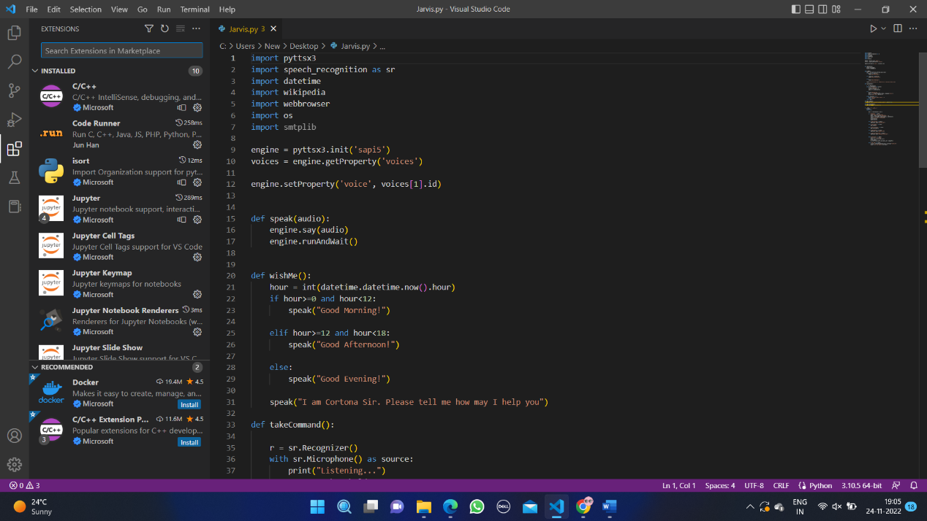

Fig.2.2.1 VS Code IDE

PYQT5 FOR LIVE GUI

PyQt5 is the most important python binding. It contains set of GUI widgets.

PyQt5 has some important python modules like QTWidgets, QtCore, QtGui, and QtDesigner etc.

**PYTHON LIBRARIES**

In JARVIS following python libraries were used:

3.3.1. pyttsx3: It is a python library which converts text to speech.

3.3.2. SpeechRecognition: It is a python module which converts speech to text.

3.3.3. pywhatkit: It is python library to send WhatsApp message at a particular time with some additional features.

3.3.4. Datetime: This library provides us the actual date and time.

3.3.5. Wikipedia: It is a python module for searching anything on Wikipedia.

3.3.6. Smtplib: Simple mail transfer protocol that allows us to send mails and to route mails between mail servers.

3.3.7. pyPDF2: It is a python module which can read, split, merge any PDF.

3.3.8. Pyjokes: It is a python libararies which contains lots of interesting jokes in it.

3.3.9. Webbrowser: It provides interface for displaying web-based documents to user3.3.7. pyPDF2: It is a python module which can read, split, merge any PDF.

3.3.8. Pyjokes: It is a python libraries which contains lots of interesting jokes in it.

3.3.9. Webbrowser: It provides interface for displaying web-based documents to users

3.3.10. os: It represents Operating System related functionality.

3.3.11. sys: It allows operating on the interpreter as it provides access to the variables and functions that usually interact strongly with the interpreter.

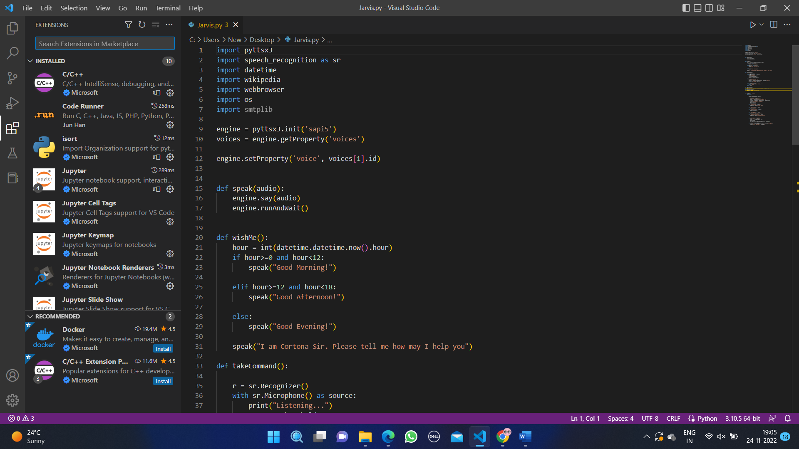

Fig. 2.2.2 Python Libraries

**2.3 Functional Requirements**

The functional requirements are as follows:

● Proper Internet Connection

● Github Credentials

● Docker installed

● Python 2.7

● Heroku CLI

● Mplayer for voice support (Text-to-Speech)

● Chromium-based browser, like Chrome, Edge

● It should be able to handle ‘GIFs’ and ‘jpeg’ image.

● It should have all the libraries installed.

●Ability to add coded responses using voice.

● Indirectly communicate with the rest of the Hardware and Software.

**2.4 Non-Functional Requirements**

The non-functional requirements of the system include:

* The system ensures safety which are observable during operation.
* The system is adaptable to different situations.
* The project has good and compact UI using AngularJS with responsive interface.
* The project is light on resources.
* The program should be platform independent**.**
* The system must ensures security from an external and internal threats.
* The system ensures safety which are observable at run time.
* The system must provide some alternatives to voice controlled actions.
* There should be manual control to JARVIS.
* Ability to add coded responses using voice.
* Indirectly communicate with the rest of the Hardware and Software.
  + Implement a robust backup system to ensure data integrity and quick recovery in case of failures.

**2.5 User classes and Characteristics**

There are mainly two type of users such as user and admin. The admin will be a technical person who can fix any problem related to the system or software and he can also take data from system. The user will know the basic operational procedure to run the system. Lecturer don’t need to have technical details. But user must know how to run system and check attendance. The interface and design will be user friendly and can be easily understand by the users.

**3. System Design**

**3.1 Use Case Diagram**

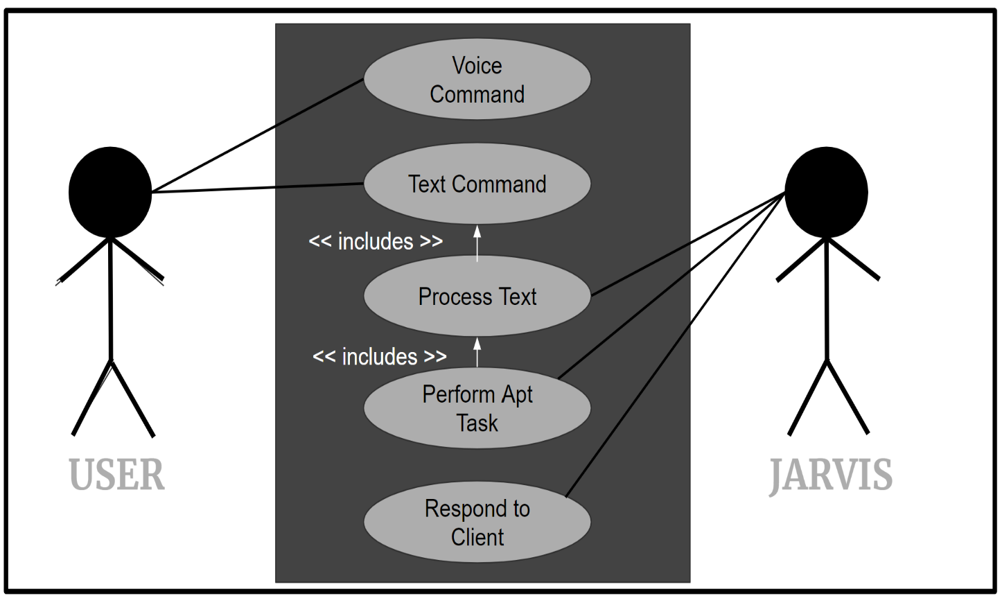

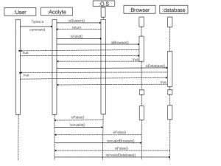 **3.2 Sequence Diagram**

**3.3 Activity Diagram**

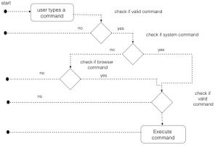

**3.4 Deployment Diagram**

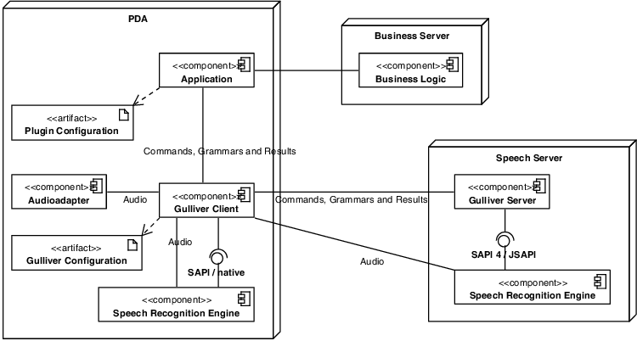

**3.5 E-R Diagram**

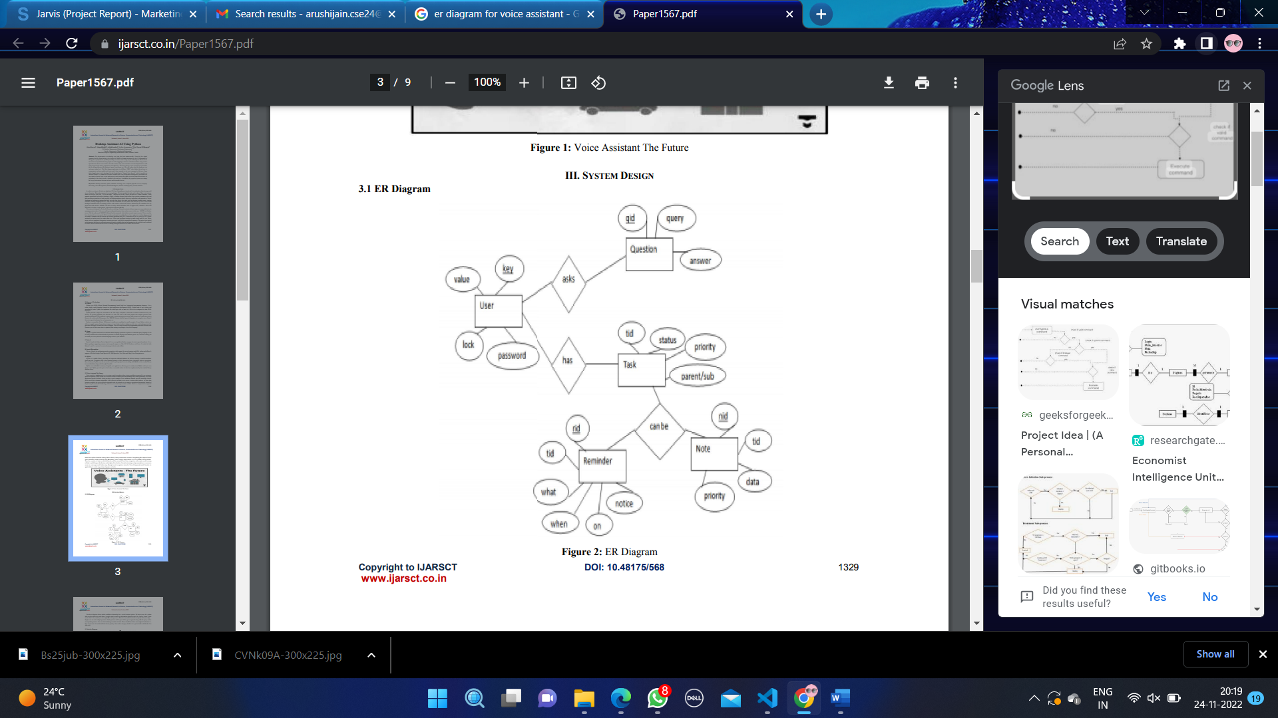

**Artificial Intelligence:**

Artificial Intelligence is the science and engineering of making intelligent machines, especially intelligent computer programs. It is concerned with getting computers to do tasks that would normally require human intelligence. AI systems are basically software systems (or controllers for robots) that use techniques such as machine learning and deep learning to solve problems in particular domains without hard coding all possibilities (i.e. algorithmic steps) in software. Due to this, AI started showing promising solutions for industry and businesses as well as our daily lives.

Advances in computing and digital technologies have a direct influence on our lives, businesses and social life. This has influenced our daily routines, such as using mobile devices and active involvement on social media. AI systems are the most influential digital technologies. With AI systems, businesses are able to handle large data sets and provide speedy essential input to operations. Moreover, businesses are able to adapt to constant changes and are becoming more flexible.

By introducing Artificial Intelligence systems into devices, new business processes are opting for the automated process. A new paradigm emerges as a result of such intelligent automation, which now dictates not only how businesses operate but also who does the job. Many manufacturing sites can now operate fully automated with robots and without any human workers. Artificial Intelligence now brings unheard and unexpected innovations to the business world that many organizations will need to integrate to remain competitive and move further to lead the competitors.

Artificial Intelligence shapes our lives and social interactions through technological advancement. There are many AI applications which are specifically developed for providing better services to individuals, such as mobile phones, electronic gadgets, social media platforms etc. We are delegating our activities through intelligent applications, such as personal assistants, intelligent wearable devices and other applications. AI systems that operate household apparatus help us at home with cooking or cleaning.

**Types of AI:**

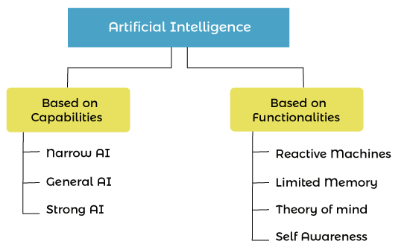

Fig 4.1. Types of AI

On the basis of Capability, AI can be divided into mainly three types:

* 1. Narrow AI or Weak AI - Narrow AI or Weak AI is a basic kind of Artificial Intelligence, which is capable of completing dedicated tasks with intelligence. The current version of AI is narrow AI. Narrow AI can only perform the specific task and not beyond its limitation, as they are trained for one task only. It is programmed to do a specific task such as Play Chess, Checking Weather, etc.
  2. General AI - Artificial General intelligence or "Strong" AI defines the machines that can show human intelligence. We can say, Machines with AGI can successfully perform any intellectual task that a human can do. This is the sort of AI that we see in movies like "Her" or other sci-fi movies in which humans interact with machines and operating systems that are conscious, sentient, and driven by emotion and self-awareness.

Currently, this type of intelligence does not exist in the real world and only exist in researches and movies. However, researchers across the world are working to develop such machines, which is still a very difficult task.

* 1. Super AI - Super AI refers to AI that is self-aware, with cognitive abilities that surpass that of humans. It is a level where machines are capable of doing any task that a human can do with cognitive properties. However, Super AI is still a hypothetical concept, and it is a challenging task to develop such AI-enabled machines.

On the basis of Functionality:

* 1. Reactive Machines - Reactive machines are the basic types of AI, which don't store memories or past experiences for their actions. These types of AI machines only focus on current scenarios and work as per the requirement with the best possible actions. IBM's Deep Blue is an example of a reactive machine.
  2. Limited Memory - Limited memory can store some memory or past experiences for a limited time period. Some examples of limited memory are Self-driving cars.
  3. **Theory of Mind** - Theory of Mind is the type of AI which are capable of understanding human emotions, and interact with the human in their way. However, such AI machines are yet not developed, and developers and researchers are making efforts for creating such AI-enabled machines.
  4. **Self-awareness** - Self-awareness AI is the future of Artificial Intelligence, which will have its own awareness, sentiments, and consciousness. This AI is only a hypothetical concept and will take a long journey and challenges to create such AI.

**Applications of AI**

1. Game Playing: AI is widely used in Gaming. Different strategic games such as Chess, where the machine needs to think logically, and video games to provide real-time experiences use Artificial Intelligence.

2. Robotics: Artificial Intelligence is commonly used in the field of Robotics to develop intelligent robots. AI implemented robots use real-time updates to sense any obstacle in their path and can change the path instantly. AI robots can be used for carrying goods in hospitals and industries and can also be used for other different purposes.

3. Healthcare: In the healthcare sector, AI has diverse uses. In this field, AI can be used to detect diseases and cancer cells. It also helps in finding new drugs with the use of historical data and medical intelligence.

4. Computer Vision - Computer vision enables the computer system to understand and derive meaningful information from digital images, video, and other visual input with the help of AI.

**5. Agriculture -** AI is now widely used in Agriculture; for example, with the help of AI, we can easily identify defects and nutrient absences in the soil. To identify these defects, AI robots can be utilized. AI bots can also be used in crop harvesting at a higher speed than human workers.

**6. E-commerce** - AI is one of the widely used and demanding technologies in the E-commerce industry**.** With AI, e-commerce businesses are gaining more profit and grow in business by recommending products as per the user requirement.

**Prerequisites for Artificial Intelligence**

As a beginner, below are some of the prerequisites that will help to get started with AI technology.

* Strong knowledge of Mathematics mainly, Calculus, Linear Algebra, Statistics and probability.
* A good experience in programming languages like Java, Python, R.
* A strong understanding of algorithms.
* Good background in data analytics skills.

**Challenges with AI**

* + Lack of data or poor-quality data

One of the big challenges with AI is that we don't have enough data to work with AI systems, or data we have is of poor quality or unstructured. AI depends on data for its working and requires a huge amount of data for a good result, but in the real world, data is available either in raw form or unstructured form that contains lots of impurities and missing values that cannot be processed or analyzed. Hence the processing of such data is a big task for organizations, and it takes lots of effort and is a time-consuming process.

* Insufficient IT infrastructure

There is still a lack of IT infrastructures, mainly in start-ups, which is a big issue in AI researches and development.

* Lack of AI talent

AI is growing continuously day by day with rapid speed, and more people are accepting the proven ideas of AI. The growing rate of AI also needs developers of AI tech. However, the professionals with full scales skills to develop high-level AI implementations are still lacking, which is also one of the big challenges with AI.

Computing Power

Computing power has always been a big issue in the IT industry, but day by day, this issue has been resolved. However, with the development of AI, this issue has arisen again. Deep learning and the processing of neural networks, which are part of AI, require a high level of computing power, and are a major challenge for the tech industries. Mainly for start-ups, collecting money and such high computing power to process the data is a big deal.

**JARVIS:**

JARVIS, a desktop assistant is 8 voice assistant that can perform many daily tasks of desktop like playing music, opening your favourite IDE with the help of a single voice ‘command, Jarvis is different from other traditional voice assistants in terms that it is specific to desktop and user does not need to make account 10 use tis, i does not quire any internet connection while getting the instructions to perform any’ specie task

**4.1. REAL LIFE APPLICATION**

4.1.1. Saves time: JARVIS is a desktop voice assistant which works on the voice command offered to it, it can do voice searching, voice-activated device control and can let us complete a set of tasks.

4.1.2. Conversational interaction It makes it easier to complete any task as it automatically do it by using the essential module or libraries of Python, in a conversational interaction way. Hence any user when instruct any task to it, they feel like giving task to a human assistant because of the conversational interaction for giving input and getting the desired output in the form of task done.

4.1.3. Reactive nature: The desktop assistant is reactive which means it know human language very well and understand the context that is provided by the user and gives response in the same way, i.e. human understandable language, English. So user finds its reaction in an informed and smart way,

4.1.4. Multitasking: The main application of it can be its multitasking ability. It can ask for continuous instruction one after other until the user "QUIT" .

* + 1. No Trigger phase: It asks for the instruction and listen the response that is given by user without needing any trigger phase and then only executes the task.
  1. **DATA IMPLEMENTATION AND PROGRAM EXECUTION**

As the first step, install all the necessary packages and libraries. The command used to install the

libraries is "pip install" and then import it. The necessary packages included are as follows:

4.2.1. LIBRARIES AND PACKAGES

4.2.2.1. pyttsx3: It is a python library which converts text to speech.

4.2.2.2. SpeechRecognition: It is a python module which converts speech to text.

4.2.2.3. pywhatkit: It is python library to send WhatsApp message at a particular time with some additional features.

4.2.2.4. Datetime: This library provides us the actual date and time.

4.2.2.5. Wikipedia: It is a python module for searching anything on Wikipedia

4.2.2.6. Smtplib: Simple mail transfer protocol that allows us to send mails and to route mails between mail servers.

4.2.2.7. pyPDF2: It is a python module which can read, split. merge any PDF.

4.2.2.8. Pyjokes: It is a python libraries which contains lots of interesting jokes in it.

4.2.2.9. Webbrowser: It provides interface for displaying web-based documents to users.

4.2. 2.10. Pyautogui: It is a python librariy for graphical user interface.

4.2.2.11. os: It represents Operating System related functionality.

4.2.2.12. sys: It allows operating on the interpreter as it provides access to the variables and functions that usually interact strongly with the interpreter

4.2.2. FUNCTIONS

4.2.2.1. takeCommand(): The function is used to take the command as input through microphone of user and returns the output as string

4.2.2.2. wishMe(): This function greets the user according to the time like Good Morning, Good Afternoon and Good Evening.

4.2.2.3. taskExecution(): This is the function which contains all the necessary task execution definition like sendEmail(), pdf reader(),etc

Features in JARVIS

* + 1. Queries from the web:

Making queries is an essential part of one’s life, and nothing changes even for a developer working on Linux. We have addressed the essential part of a netizen’s life by enabling our voice assistant to search the web. Here we have used Node JS and Selenium framework for extracting the result from the web as well as displaying it to the user. Jarvis supports a plethora of search engines like Google, Bing and Yahoo and displays the result by scraping the searched queries. In order to make queries from different search engines, the given format should be adopted: Jarvis supports Google, Bing and Yahoo, which should precede the desired query.

* + 1. Accessing youtube videos-

Video have remained as a main source of entertainment, one of the most prioritized tasks of virtual assistants. They are equally important for entertainment as well as educational purposes as most teaching and research activities in present times are done through Youtube. This helps in making the learning process more practical and out of the four walls of the classroom. Jarvis implements the feature through a subprocess module which is handled by the main Golang service. This service initiates the subprocess for Node JS which serves the Selenium WebDriver, and scraps the searched YouTube query.

* + 1. Get weather for a location –

Getting live weather conditions about a place remains an important task of virtual assistants. It helps the user charter the course of their action. Jarvis addresses this issue with the help of Python4. Retrieve images Users could get images directly through the Jarvis interface. This implementation is done using the Selenium WebDriver. The images are derived as iframes from the entire web code received from Google images. These are formatted according to use and displayed in a compact manner in the Jarvis interface

* + 1. Dictionary meaning –

One of the usages of the web is to find word meaning and its usage in our day to day life. Instead of going through the bulky books, our users can simply search for it using the voice assistant and get the meaning within a fraction of seconds.

* + 1. Medicine Details-

One of the important issue Jarvis addresses is of healthcare, and medicine in general. The user can query either the medicine or the symptoms. The former lets you know the complete details of the medicine, like indications, contradictions, trade or brand names, dosage, the process of consumption, warning and precautions, storage conditions, etc. On the other hand, the symptom feature lets you query about the symptoms while Jarvis lists various diseases one is likely to be affected along with their medicine. This is helpful for people who are quite busy with their life and find trouble visiting the doctor immediately, thus relying on the web to find the best result for short term cause.

* + 1. Sending Emails-

Integrating mailing features to Jarvis eases the job of mailing, which otherwise would have to be done by opening the concerned email address. With Jarvis, you do not need to go for another tab to do one of the major task of your day to day affairs. The user can send emails to the desired receiver. He should input Send mail, after which a form will be displayed. Fill the form with the required details and click on the send mail button.

Why to use Jarvis?

1. It fulfils the lack of a virtual assistant in Linux systems.

2. It has an easy to install and use interface.

3. It accepts inputs even through voice or keyboard.

4. It automates tedious tasks like deployment, unit testing through a single command.

5. It gives live weather updates

6. It gives advice on health.

* 1. **Screenshots**

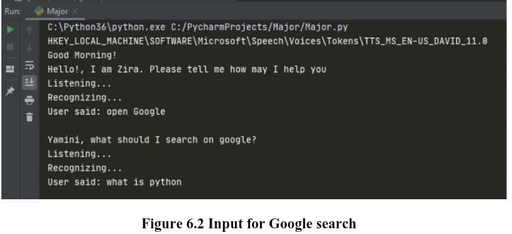

Fig 5.1 Input for Google Search

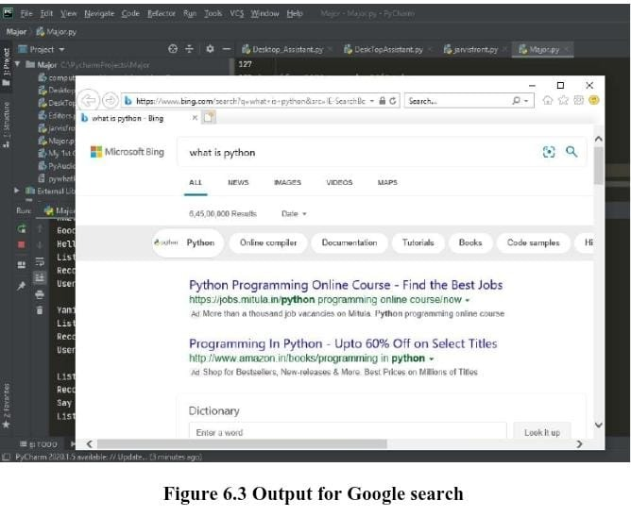

Fig 5.2 Output for Google Search

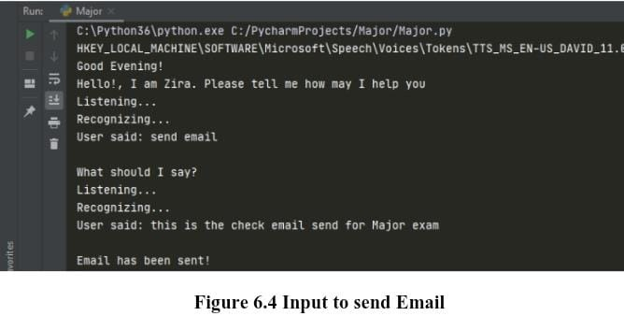

Fig 5.3 Input to send Email

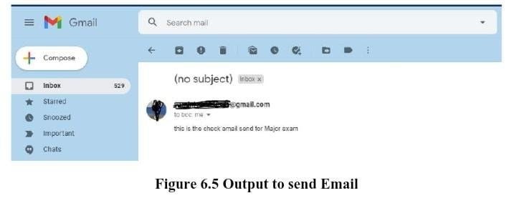

Fig 5.4 Output to send Email

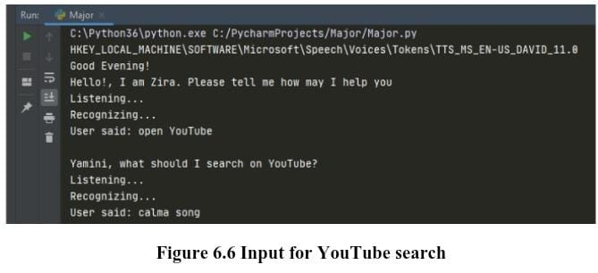

Fig 5.5 Input for YouTube search

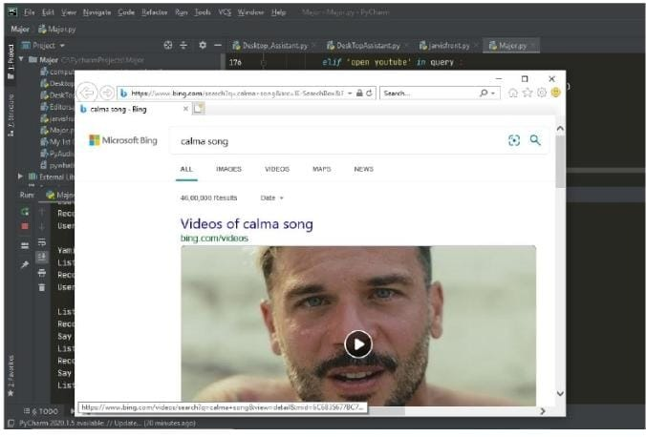

Fig 5.6 Output for YouTube search

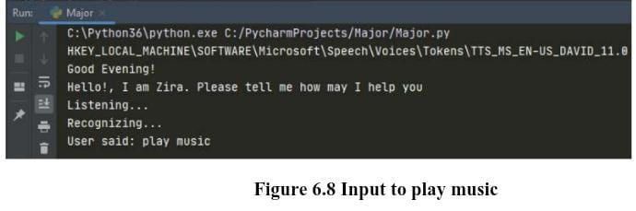

Fig 5.5 Input to Play Music

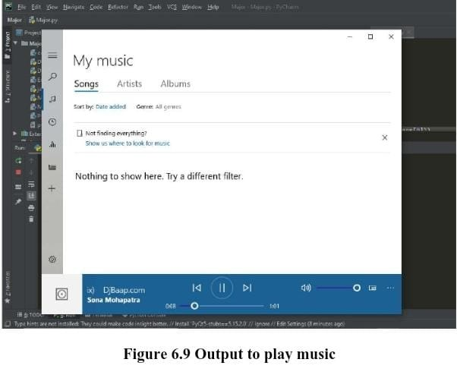

Fig 5.6 Output to Play Music

1. **Conclusion**

JARVIS is a very helpful voice assistant without any doubt as it saves time of the user by conversational interactions, its effectiveness and efficiency. But while working on this project, there were some limitations encountered and also realized some scope of enhancement in the future which are mentioned below.

6.1. LIMITATIONS

6.1.1. Security is somewhere an issue, there is no voice command encryption in this project.

6.1.2. Background voice can interfere

6.1.3. Misinterpretation because of accents and may cause inaccurate results.

6.1.4. JARVIS cannot be called externally anytime like other traditional assistants like Google Assistant can be called just by saying, "Ok Google!"

6.2. SCOPE FOR FUTURE WORK

6.2.1. Make JARVIS to learn more on its own and develop a new skill in it.

6.2.2. JARVIS android app can also be developed.

6.2.3. Make more Jarvis voice terminals

**6**. References

* Upflairs Pvt.ltd
* JavatPoints - <https://www.javatpoint.com/>
* W3school - <https://www.w3schools.com/>
* Geeksforgeeks - https://www.geeksforgeeks.org

THANK YOU